A PROJECT SYNOPSIS

ON

# “PDM FACE RECOGNITION BASESD ATTENDANCE SYSTEM”

Submitted in partial fulfillment of the requirement for the award of degree of

## BACHELOR OF TECHNOLOGY

IN

# Computer Science & Engineering

**TEAM MEMBERS:**

**Abhinav Kumar(A40318046)**

**Muskan chauchan (A40318075)**

**Ravi Yadav(A40318039)**

**Shalu Sharma(A40318054)**

**Kavita Singh(A40318083)**

**Batch: 2018-2022**

**PROJECT GUIDE:**

Mr. Tarun Dalal (AP, CSE Dept)



# Department of Computer Science & Engineering Faculty of Engineering & Technology

**P.D.M. University, Bahadurgarh**

**INDEX**

## Abstract

1. **Introduction**
2. **Scope & Objective of the Project**
3. **Tools and Technology used**
4. **Technical Details**
5. **Methodology**

**References**

**Project Title:**

**PDM FACE RECOGNITION BASESD ATTENDANCE SYSTEM**

**Team Members: (5)**

|  |  |  |  |  |
| --- | --- | --- | --- | --- |
| 1. | Name: ABHINAV KUMAR | | Roll No.: A40318046 | |
|  |  | | Branch: B-tech CSE General | |
|  |  | | E-mail: ak1a18@pdm.ac.in | |
| 2. | Name: MUSKAN CHAUHAN | | Roll No.: A40318075 | |
|  |  | | Branch: B-tech CSE General | |
|  |  | | E-mail: mc1a18@pdm.ac.in | |
| 3. | Name: SHALU SHARMA | | Roll No.: A40318054 | |
|  |  | | Branch: B-tech CSE General | |
|  |  | | E-mail: ss4a18@pdm.ac.in | |
|  |  | |  | |
| 4. Name: KAVITA SINGH Roll | | Roll No.: A40318062 Roll No.: A40318083 | |
|  | | Branch: B-tech CSE General | |
|  | | E-mail: ka1a18@pdm.ac.in | |
| 5. Name: RAVI YADAV | | Roll No.: A40318039 | |
|  | | Branch: B-tech CSE General | |
|  | | E-mail: ry1a18@pdm.ac.in | |

**ABSTRACT**

# Automatic face recognition (AFR) technologies have seen dramatic improvements in performance over the past years, and such systems are now widely used for security and commercial applications. An automated system for human face recognition in a real time background for a college to mark the attendance of their employees. So Smart Attendance using Real Time Face Recognition is a real world solution which comes with day to day activities of handling employees. The task is very difficult as the real time background subtraction in an image is still a challenge . To detect real time human face are used and a simple fast Principal Component Analysis has used to recognize the faces detected with a high accuracy rate. The matched face is used to mark attendance of the employee.Our system maintains the attendance records of employees automatically. Manual entering of attendance in logbooks becomes a difficult task and it also wastes the time. So we designed an efficient module that comprises of face recognition to ma age the attendance records of employees. Our module enrols the staff’s face . This enrolling is a onetime process and their face will be stored in the database. During enrolling of face we require a system since it is a onetime process. You can have your own roll number as your employee id which will be unique for each employee. The presence of each employee will be updated in a database. The results showed improved performance over manual attendance management system. Attendance is marked after employee identification. This product gives much more solutions with accurate results in user interactive manner rather than existing attendance and leave management systems.

# INTRODUCTION

# Maintaining the attendance is very important in all the institutes for checking the performance of employees . Every institute has its own method in this regard. Some are taking attendance manually using the old paper or file based approach and some have adopted methods of automatic attendance using some biometric techniques. But in these methods employees have to wait for long time in making a queue at time they enter the office. Many biometric systems are available but the key authentications are same is all the techniques.

# Every biometric system consists of enrolment process in which unique features of a person is stored in the database and then there are processes of identification and verification. These two processes compare the biometric feature of a person with previously stored template captured at the time of enrollment. Biometric templates can be of many types like Fingerprints, Eye Iris, Face, Hand Geometry, Signature, Gait and voice. Our system uses the face recognition approach for the automatic attendance of employees in the office room environment without employees’ intervention . Face recognition consists of two steps, in first step faces are detected in the image and then these detected faces are compared with the database for verification. A number of methods have been proposed for face detection i.e. Ada Boost algorithm, the Float Boost algorithm, the S-Ada Boost algorithm Support Vector Machines (SVM), and the Bayes classifier. The efficiency of face recognition algorithm can be increased with the fast face d tection algorithm. In all the above methods SURF is most efficient. Our system utilized this algorithm for the detection of faces in the office room image. Face recognition techniques can be Divided into two types Appearance based which use texture features that is applied to whole face or some specific Regions, other is Feature based which uses geometric features like mouth, nose, eyes, eye brows, cheeks and Relation between them. Statistical tools such as Linear Discriminant Analysis (LDA), Principal Component Analysis (PCA), Kernel Methods, and Neural Networks, Eigen-faces have been used for construction of face templates. Illumination invariant algorithm is utilized for removing the lighting effect inside the office room.

# SYSTEM DESCRIPTION

# The system consists of a camera that captures the images of the employee and sends it to the image enhancement module. After enhancement the image comes in the Face Detection and Recognition modules and then the attendance is marked on the database server. This is shown in the experimental setup in Figure. At the time of enrolment, templates of face images of individual employees are stored in the Face database. Here all the faces are detected from the input image and the algorithm compares them one by one with the face database. If any face is recognized the attendance is marked on the server from where anyone can access and use it for different purposes. In this way a lot of time is saved and this is highly secure process no one can mark the attendance of other. Attendance is maintained on the server so anyone can access it for purposes like administration, employees themselves. In order to avoid the false detection we are using the skin classification technique. Using this technique enhance the efficiency and accuracy of the detection process. In this process first the skin is classified and then only skin pixels remains and all other pixels in the image are set to black, this greatly enhance the accuracy of face detection process. Two databases are displayed in the experimental setup. Face Database is the collection of face images and extracted features at the time of enrolment process and the second attendance database contains the information about the employees and also uses to mark attendance.

# FRONTEND

# We are using TKINTER and OS for the frontend part and operating system interfaces.

# We are using PYTHON-DATEUTIL for system data identification.

# We are using PYTHON-TIME for system time identification.

# BACKEND

# We are using OPENCV for the computer vision, machine learning and image processing.

# We are using NUMPY for mathematical calculation.

# We are using PANDAS for the operations for manipulating numerical data and time series.

# We are using PIL for lightweight image processing that aids in editing, creating and saving images.

# We are using python CSV for creating a comma separated files to analyze data.

# And we are using HAAR CASCADE classification for object and image detection.

# TKINTER

# Python offers multiple options for developing GUI (Graphical User Interface). Out of all the GUI methods, tkinter is the most commonly used method. It is a standard Python interface to the Tk GUI toolkit shipped with Python. Python with tkinter is the fastest and easiest way to create the GUI applications. Creating a GUI using tkinter is an easy task.

# To create a tkinter app:

# Importing the module – tkinter

# Create the main window (container)

# Add any number of widgets to the main window

# Apply the event Trigger on the widgets.

# OS

# The OS module in Python provides functions for interacting with the operating system. OS comes under Python’s standard utility modules. This module provides a portable way of using operating system-dependent functionality. The *os* and *os.path* modules include many functions to interact with the file system.The OS module in Python provides functions for interacting with the operating system. OS comes under Python’s standard utility modules. This module provides a portable way of using operating system-dependent functionality. The *os* and *os.path* modules include many functions to interact with the file system.

# PYTHON TIME

# Time module in Python provides various time-related functions. This module comes under Python’s standard utility modules.

# time.time() method of Time module is used to get the time in seconds since epoch. The handling of leap seconds is platform dependent.

# Note: The epoch is the point where the time starts, and is platform dependent. On Windows and most Unix systems, the epoch is January 1, 1970, 00:00:00 (UTC) and leap seconds are not counted towards the time in seconds since the epoch. To check what the epoch is on a given platform we can use time.gmtime(0).

# PYTHON DATE-UTILS

# The parser module can parse datetime strings in many more formats. There can be no better library than dateutil to parse dates and times in Python. To lookup the timezones, the tz module provides everything. When these modules are combined, they make it very easy to parse strings into timezone-aware datetime objects.

# OPENCV

# OpenCV is a huge open-source library for computer vision, machine learning, and image processing. OpenCV supports a wide variety of programming languages like Python, C++, Java, etc. It can process images and videos to identify objects, faces, or even the handwriting of a human. When it is integrated with various libraries, such as Numpy which is a highly optimized library for numerical operations, then the number of weapons increases in your Arsenal i.e whatever operations one can do in Numpy can be combined with OpenCV.

# This OpenCV tutorial will help you learn the Image-processing from Basics to Advance, like operations on Images, Videos using a huge set of Opencv-programs and projects.

# NUMPY

# Numpy is a general-purpose array-processing package. It provides a high-performance multidimensional array object, and tools for working with these arrays. It is the fundamental package for scientific computing with Python.

# Besides its obvious scientific uses, Numpy can also be used as an efficient multi-dimensional container of generic data.

### ****PANDAS****

Pandas is an open-source library that is built on top of NumPy library. It is a Python package that offers various data structures and operations for manipulating numerical data and time series. It is mainly popular for importing and analyzing data much easier. Pandas is fast and it has high-performance & productivity for users.

**PILLOW (a fork of PIL)**

Python Imaging Library (expansion of PIL) is the de facto image processing package for Python language. It incorporates lightweight image processing tools that aids in editing, creating and saving images. Support for Python Imaging Library got discontinued in 2011, but a project named pillow forked the original PIL project and added Python3.x support to it. Pillow was announced as a replacement for PIL for future usage. Pillow supports a large number of image file formats including BMP, PNG, JPEG, and TIFF. The library encourages adding support for newer formats in the library by creating new file decoders.

**PYTHON CSV**

CSV (Comma Separated Values) is a simple file format used to store tabular data, such as a spreadsheet or database. A CSV file stores tabular data (numbers and text) in plain text. Each line of the file is a data record. Each record consists of one or more fields, separated by commas. The use of the comma as a field separator is the source of the name for this file format.

**HAARCASCADE**

Haar Cascade classifiers are an effective way for object detection. This method was proposed by Paul Viola and Michael Jones in their paper Rapid Object Detection using a Boosted Cascade of Simple Features .Haar Cascade is a machine learning-based approach where a lot of positive and negative images are used to train the classifier.

Positive images – These images contain the images which we want our classifier to identify.

Negative Images – Images of everything else, which do not contain the object we want to detect.

**Local Binary Patterns Histograms (LBPH)**.

**Local Binary Pattern**(LBP) is a simple yet very efficient texture operator which labels the pixels of an image by thresholding the neighborhood of each pixel and considers the result as a binary number.

It was first described in 1994 (LBP) and has since been found to be a powerful feature for texture classification. It has further been determined that when LBP is combined with histograms of oriented gradients (HOG) descriptor, it improves the detection performance considerably on some datasets.Using the LBP combined with histograms we can represent the face images with a simple data vector.

The first computational step of the LBPH is to create an intermediate image that describes the original image in a better way, by highlighting the facial characteristics. To do so, the algorithm uses a concept of a sliding window, based on the parameters **radius** and **neighbors** and hence it compute the identification of object and image surrounding.

**SYSTEM ALGORITHM**

This section describes the software algorithm for the system.

The algorithm consists of the following steps

* Image acquisition
* Histogram normalization
* Noise removal
* Skin classification
* Face detection
* Face recognition
* Attendance

# In the first step image is captured from the camera. There are illumination effects in the captured image because of different lighting conditions and some noise which is to be removed before going to the next steps. Histogram normalization is used for contrast enhancement in the spatial domain. Median filter is used for removal of noise in the image. There are other techniques like FFT and low pass filter for noise removal and smoothing of the images but median filter gives good results.

# Flow and Processing Of Algorithm

# 

# 

# OBJECTIVE & SCOPE

# Automated Attendance System has been envisioned for the purpose of reducing the errors that occur in the traditional (manual) attendance taking system. The aim is to automate and make a system that is useful to the organization such as an institute. The efficient and accurate method of attendance in the office environment that can replace the old manual methods. This method is secure enough, reliable and available for use. No need for specialized hardware for installing the system in the office. It can be constructed using a camera and computer.The implementation of the Smart Attendance System portrays the existence of an agreement between the appropriate recognition rate and the threshold value. Therefore LBPH is the most authentic and competent face recognition algorithm found in Open CV for the identification of the students in an educational institute and marking their attendance adequately by averting proxies.

# TECHNICAL DETAILS

## SOFTWARE REQUIREMENTS:

* Python == 3.6.7
* tkinter==1.3.3, os-sys==2.1.4 , six==1.16.0(Front End)
* numpy == 1.21.2 , opencv-python==4.5.3.56 , pa https://pandas.pydata.org/ndas==1.3.2 , pillows==8.3.2 , python-datautil==2.8.2 (Back End)
* Microsoft Windows , Linux , Mac (All OF THEM)
* Internet Explorer (5.0 and above) or Mozilla Firefox (6.0 and above)
* VSCODE text editor , A Bash terminal / command prompt.

## HARDWARE REQUIREMENTS:

* Intel core 2 (minimum spec)
* Ram :- 2 GB
* Computer Memory :- 128 GB
* Intel HD graphics (minimum version 15.40.46.5144)

# METHODOLOGY

Agile is a set of techniques to manage software development projects. It consists in: • Being able to respond to changes and new requirements quickly. • Teamwork, even with the client. • Building operating software over extensive documentation. • Individuals and their interaction over tools. We believed it was a perfect fit for our project since we did not know most requirements beforehand. By using the Agile, we were able to focus only on the features which had the most priority at the time.

* **Agile project management** is an iterative approach to **project management** which allows you to break large projects down into more manageable tasks tackled in short iterations or sprints. This enables your team to adapt to change quickly and deliver work fast.

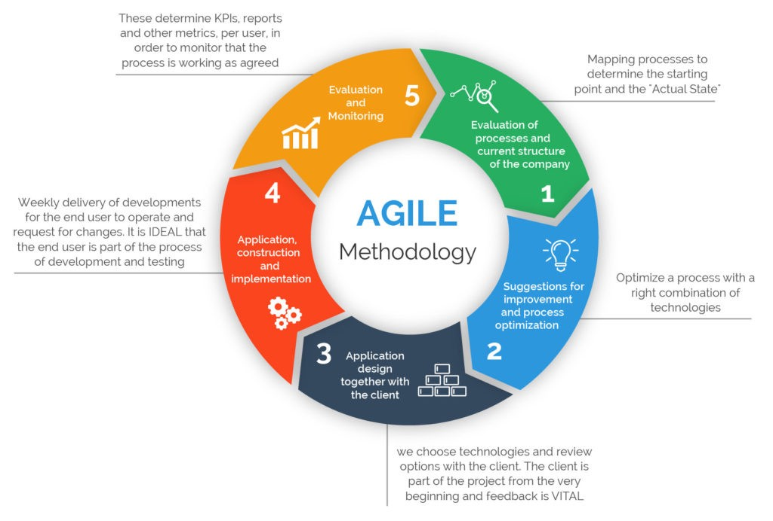

**REFERENCES**

1. <https://www.python.org/>
2. <https://docs.python.org/3/library/tkinter.html>
3. <https://docs.python.org/3/library/os.html>
4. <https://docs.python.org/3/library/datetime.html>
5. <https://pypi.org/project/python-dateutil/>
6. <https://numpy.org/>
7. <https://docs.opencv.org/4.5.0/d6/d00/tutorial_py_root.html>
8. <https://pillow.readthedocs.io/en/stable/>
9. <https://pandas.pydata.org/>
10. <https://towardsdatascience.com/face-recognition-how-lbph-works-90ec258c3d6b>